Mini Project Report

On

“Face Recognition For Attendance”

Group No. 13

Submitted by

Mansi Chandra (1801413029)

Amisha Saxena (1801413001)

Tamanna Jawrani (1801413056)

Project Guide

Mr. Lalit Kumar Narayan

Submitted to

“Mr. Manoj Kumar”



Department of Information Technology   
Shri Ram Murti Smarak College of Engineering and Technology Bareilly

**TABLE OF CONTENTS**

DECLARATION ...................................................................... iii

CERTIFICATE .................................................................. iv

ACKNOWLEDGEMENTS ........................................................ v

ABSTRACT ................................................................................ vi

CHAPTER 1 Introduction ………………………………………….. vii

.

CHAPTER 2 General Aspect

2.1 Problem Formulation …………………………………………. viii

2.2 Motivation …………………………………………………….. ix

.

CHAPTER 3

3.1. Approach ………………………………………………………. x

3.2. Flowchart……………………………………………………….. xi

3.3 Methodology…………………………………………………….. xii

3.3 Tools And Technology…………………………………………… xvi

CHAPTER 4 Testing

4.1 Output Screenshot……………………………………………….. xvii

CHAPTER 5 Future Scope and Conclusion……………………………. xix

REFERENCES……………………………………………………………. xxi

**DECLARATION**

*I hereby declare that this submission is my own work and that, to the best of my knowledge and belief, it contains no material previously published or written by another person nor material which to a substantial extent has been accepted for the award of any other degree or diploma of the university or other institute of higher learning, except where due acknowledgment has been made in the text.*

*Signature………………………………… Signature………………………………*

*Name…………………………………….. Name…………………………………..*

*Roll No………………………………….. Roll No…………………………………*

*Date…………………………………….. Date…………………………………….*

*Signature………………………………… Signature………………………………*

*Name…………………………………….. Name…………………………………..*

*Roll No………………………………….. Roll No…………………………………*

*Date…………………………………….. Date……………………………………*

## CERTIFICATE

*This is to certify that the Project Report entitled Face Recognition For Attendance which is submitted by Mansi Chandra(1801413029), Amisha Saxena (1801413001), Tamanna Jawrani (1801413056) is a record of the candidates own work carried out by them under my supervision. The matter embodied in this work is original and has not been submitted for the award of any other work or degree.*

Dr. L. S. Maurya Mr. Manoj Kumar Mr. Lalit Kumar Narayan

**HOD (CS&IT) Mini Project Incharge ( IT) Project Guide**

ACKNOWLEDGEMENT

*It gives us a great sense of pleasure to present the report of the B. Tech Project undertaken during B. Tech. Third Year. We owe special debt of gratitude to Assistant Professor Mr. Lalit Kumar Narayan, <Department name>, S.R.M.S.C.E.T, Bareilly for his constant support and guidance throughout the course of our work. His sincerity, thoroughness and perseverance have been a constant source of inspiration for us. It is only his cognizant efforts that our endeavors have seen light of the day.*

*We also take the opportunity to acknowledge the contribution of Dr. L. S. Maurya, Head, Department of Computer Science & Engineering/Information Technology, S.R.M.S.C.E.T, Bareilly for his full support and assistance during the development of the project.*

*We also do not like to miss the opportunity to acknowledge the contribution of all faculty members of the department for their kind assistance and cooperation during the development of our project. Last but not the least, we acknowledge our friends for their contribution in the completion of the project.*

*Signature………………………………… Signature………………………………*

*Name…………………………………….. Name…………………………………..*

*Roll No………………………………….. Roll No…………………………………*

*Date…………………………………….. Date…………………………………….*

*Signature………………………………… Signature………………………………*

*Name…………………………………….. Name…………………………………..*

*Roll No………………………………….. Roll No…………………………………*

*Date…………………………………….. Date……………………………………*

**ABSTRACT**

*Uniqueness or individuality of an individual is his face. In this project face of an individual is used for the purpose of attendance making automatically. Attendance of the student is very important for every college, universities and school. Conventional methodology for taking attendance is by calling the name or roll number of the student and the attendance is recorded. Time consumption for this purpose is an important point of concern. Assume that the duration for one subject is around 60 minutes or 1 hour & to record attendance takes 5 to 10 minutes. For every tutor this is consumption of time. To stay away from these losses, an automatic process is used in this project which is based on image processing. In this project face detection and face recognition is used. Face detection is used to locate the position of face region and face recognition is used for marking the understudy’s attendance. The database of all the students in the class is stored and when the face of the individual student matches with one of the faces stored in the database then the attendance is recorded.*

**CHAPTER 1**

**Introduction**

*In the 21st century, everything around us has become depends upon technology to make our life much easier. Daily tasks are continuously becoming computerized. Nowadays more people prefer to do their work electronically. To the best of our knowledge, the process of recording student’s attendance at the university is still manual. Lecturers go through manual attendance sheets and signed papers to record attendance. This is slow, inefficient and time consuming. The main objective of this project is to offer system that simplify and automate the process of recording and tracking student’s attendance through face detection technology. It is biometric technology to identify or verify a person from a digital image or surveillance video. Face detection is widely used nowadays in different areas such as universities, banks, airports, and offices. We will use pre-processing techniques to detect, recognize and verify the captured faces like Eigenfaces method. We aim to provide a system that will make the attendance process faster and more precisely. The core problem is identified along with solutions and project path. Furthermore, detailed system analysis and design, user interface, methods and the estimated results are presented through our documentation.*

**CHAPTER 2**

**General Aspects**

**2.1 Problem Formulation**

*Taking and tracking student’s attendance manually, losing attendance sheets, wasted time and high error scales are problems facing the lecturers use the existing attendance system. It is a hard process, take time and cause a lot of paper-based work. As a result, in order to solve these problems and avoid errors, we can use the technology like face detection to computerize this process by providing a system that record and manage student’s attendance automatically without needing to lecturer’s interference.*

**2.2 Motivation**

*Face recognition has recently received a blooming attention and interest from the scientific community as well as from the general public. The interest from the general public is mostly due to the recent events of terror around the world, which has increased the demand for useful security systems. Facial recognition applications are far from limited to security systems.*

*We are using this technology for automatic attendance system which can help the lecturers to maintain the attendance records of students without wasting the paper and time.*

**CHAPTER 3**

**3.1 Approach**

**Recognizing an unknown face**

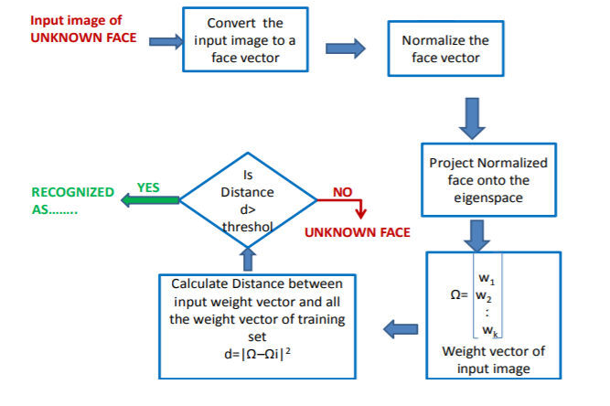

**3.2 Flow Chart**

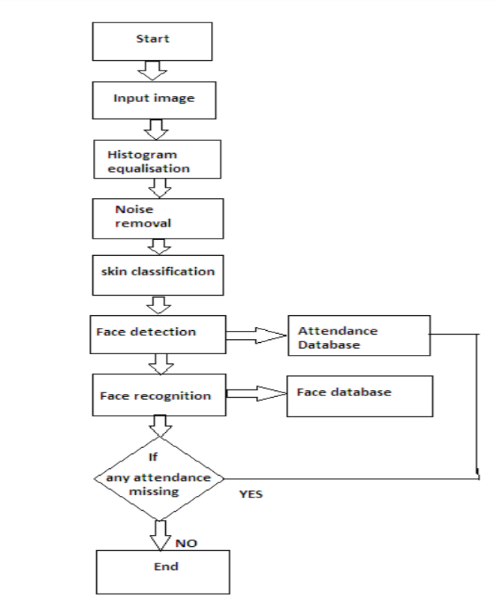

**3.3 Methodology**

1. **Basic Face Matching**

* *First, we get the location of where exactly the face is in the image using face_location() method (which gets the outline of the face) on the RGB image. Then face encodings(markings of eyes, nose, mouth, jaws which remain the same for different images of the same person) are taken using face_encodings() function which returns a list containing 128 measurements. Both these two steps are followed for the original and test image. Then a comparison between these two returned lists is done by the function compare_faces() which returns a list of boolean values(True or False). The*

*face distance function gets the value of that by how much the two images differ. The lower the distance the better the matching and vice versa.*

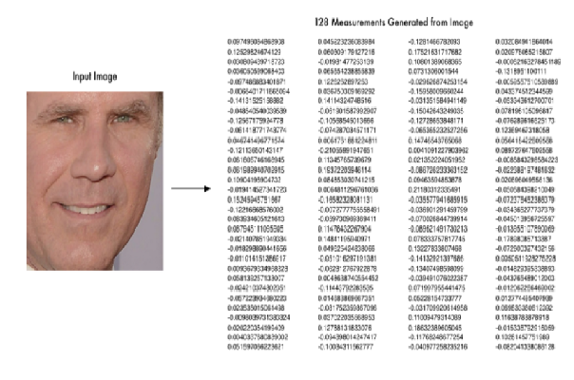

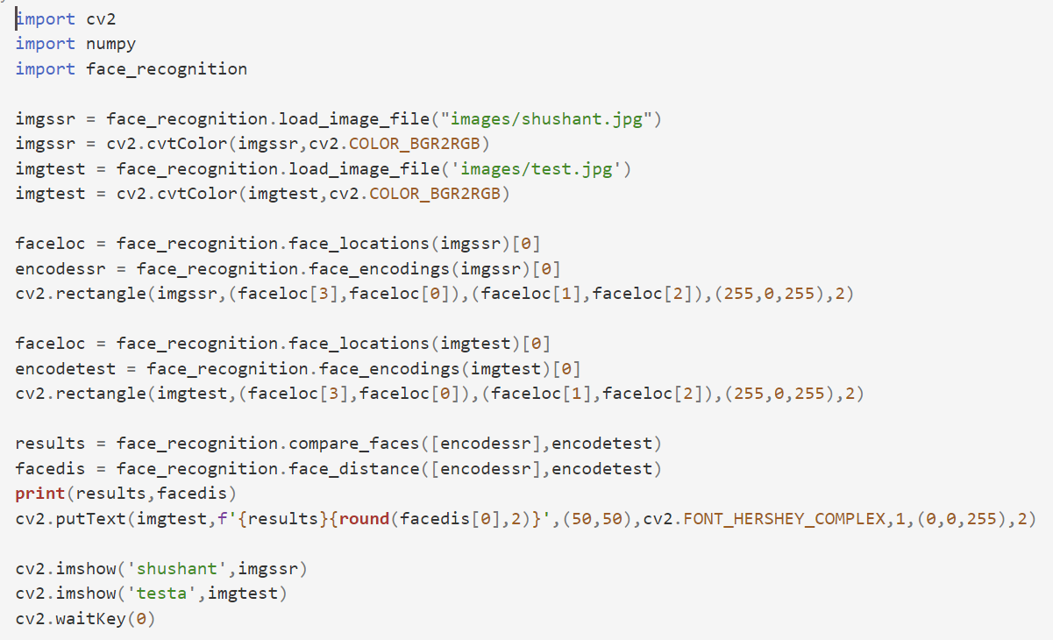

1. **Building Face Attendance System**

* *Now we are ready to build a Realtime face attendance system wherein webcam captured frames will be matched against the existing database images and if the match is found then it will store it in a CSV file called ‘Attendance.csv’ along with name and Datetime of capture. Only once the file will store the matched image’s details, if the same image is received again then it’ll not update.*
* *Path setting to the directory containing the image database. Read each image and the images array. Append the filenames into a list called Names and remove the extension.*

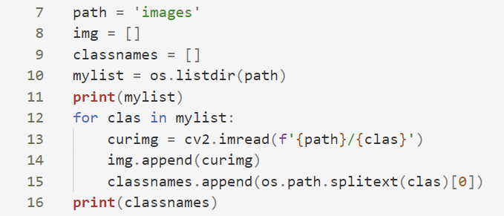

* *Finding face encodings of images in the database and keeping them in a list to use later with incoming frames.*

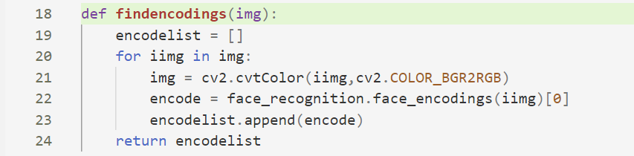

1. **Capturing video frames**



*The same process is followed by the first detection face location then getting the face encoding values.*

1. **Now the incoming images are tested against the previously-stored encodings .Then the face**

**distance is also computed. Lastly, we call the Attendance function along with the person name**

**who is identified.**

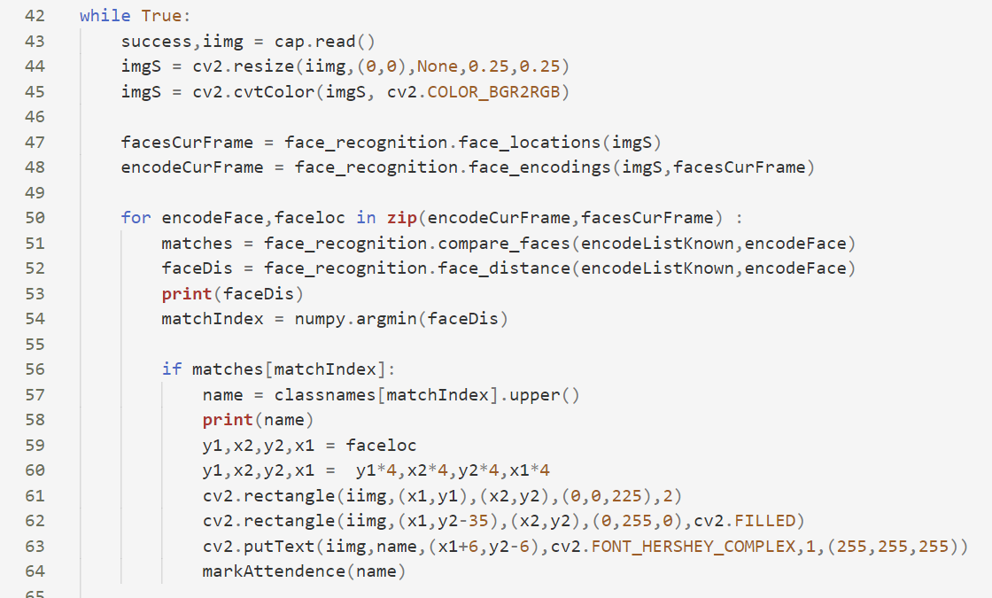

1. **Reading from attendance file, Storing data (Name and Date Time of entry)**

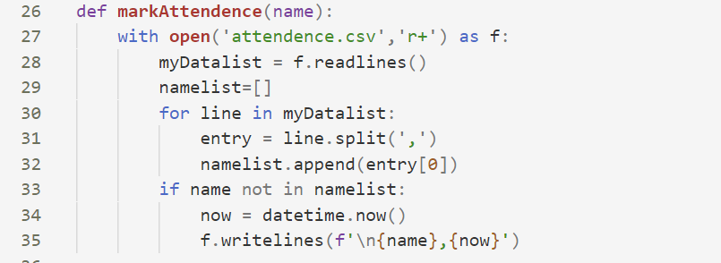

**3.4 Tools and Technology**

System Requirements: -

1. System Type - 64 Bit Operating System

2) RAM - 4 GB

3) Processor - INTEL CORE i3 (2.30 GHz)

Technology Used: -

1. Language used - Python 3.8.3 (Anaconda)

2) Libraries used - Open-CV

Face-recognition

dib

NumPy

Editor: -

1. VS Code

**Chapter-4**

**Testing**

**4.1 Output Screenshot**

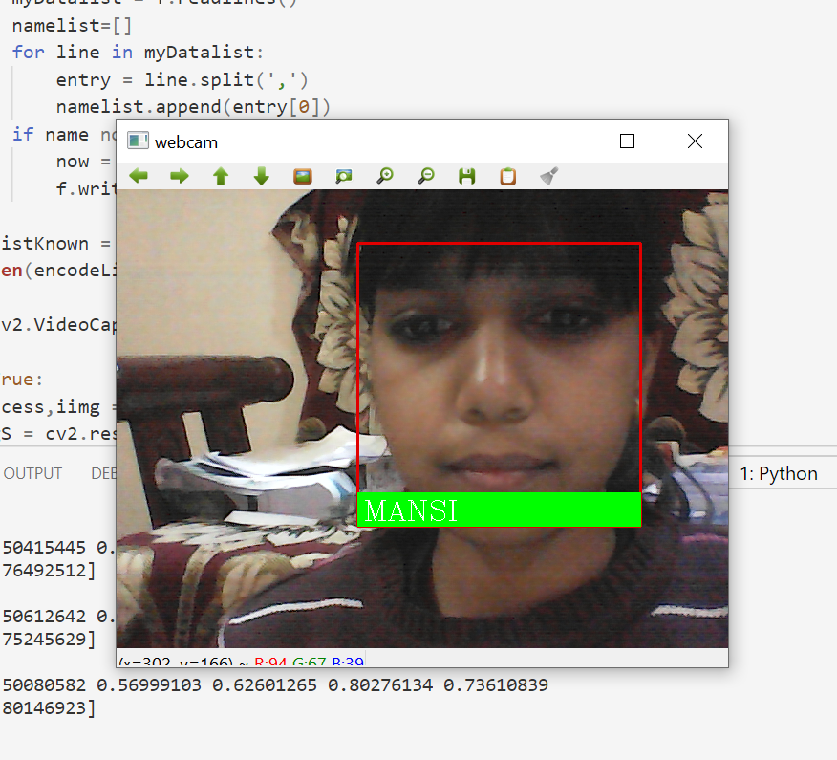

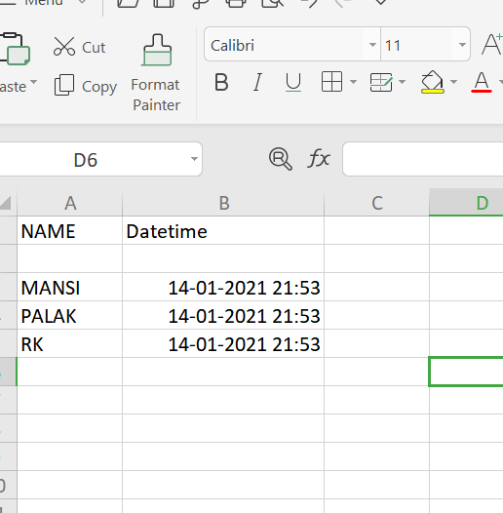

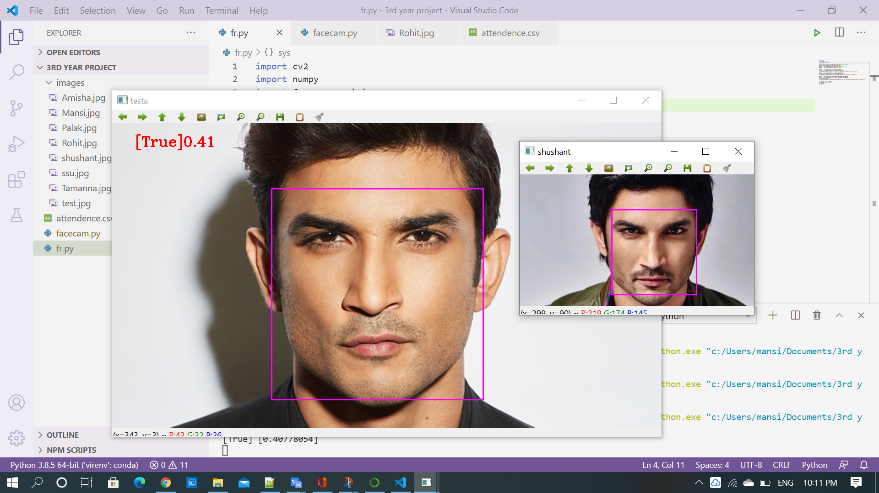

**Chapter-5**

**Future Enhancement**

* *We can make a web application by using FLASK and React JS so that students can interact with this technology in more efficient manner.*
* *We can add more features like attendance seeing system for student.*
* *We can also build the employee attendance management system.*
* *Further work can be done on this project to alert the student by sending SMS regarding the attendance. For this purpose GSM module can be used. SMS alert can be given to the parent of the student.*

**Conclusion**

Face detection library being a high-level deep learning library helps in identifying faces accurately. We have used this to build a face attendance system which can be helpful in offices, schools or any other place reducing manual labour and automatically updating the attendance records in day-to-day life. This also notes down the time of arrival thus can acquire information about people coming in late after a specified time.

**References**

* [www.google.com](http://www.google.com)
* [www.wikipedia.com](http://www.wikipedia.com)
* [www.w3schools.com](http://www.w3schools.com)
* [www.geeksforgeeks.org](http://www.geeksforgeeks.org)
* [www.tutorialspoint.com](http://www.tutorialspoint.com)
* docs.python.org/3/tutorial